CREDIT CARD FRAUD DETECTION.

1. **Design Phase Table of Contents**

**6.1 Introduction to Design Phase**

**a) Purpose of Design for Credit Card Fraud Detection Project:**

The design phase aims to establish a robust and scalable architecture for processing large volumes of transaction data in real-time. It ensures high performance for swift fraud detection and prevention. The design specifies modular system components (e.g., data collection, preprocessing, model training) to enhance maintainability and facilitate independent updates. It outlines the integration of these components with existing banking systems and third-party services. Security measures are incorporated to protect sensitive data and ensure compliance with regulations like GDPR and PCI-DSS. Additionally, the design includes strategies for monitoring, maintenance, and continuous improvement of the fraud detection system.

### b) Overview of Design Approach for Credit Card Fraud Detection Project:

The design approach focuses on a modular architecture with distinct components for data collection, preprocessing, feature engineering, model training, and evaluation. It employs scalable cloud-based solutions to handle large transaction volumes and leverages machine learning algorithms optimized through hyperparameter tuning. Real-time processing is enabled using streaming data pipelines, while APIs facilitate seamless integration with existing systems. Security is prioritized through data encryption and access controls. Continuous monitoring and automated alerts ensure timely fraud detection, and user feedback loops are implemented for ongoing system improvement. Compliance with regulations like GDPR and PCI-DSS is integral to the design.

**6.2 System Architecture**

**a) High-Level Architecture Diagram:**

### System Architecture

#### High-Level Architecture Diagram for Credit Card Fraud Detection Project

The high-level architecture comprises the following components:

1. **Data Sources:** Collect transaction data from various sources (e.g., banking systems, payment gateways).
2. **Data Ingestion Layer:** Use tools like Apache Kafka or AWS Kinesis for real-time data streaming.
3. **Data Storage:** Employ scalable databases (e.g., AWS S3, HDFS) for storing raw and processed data.
4. **Data Preprocessing:** Use ETL processes to clean and normalize data.
5. **Feature Engineering:** Create relevant features for model training, stored in a feature store.
6. **Model Training:** Utilize machine learning frameworks (e.g., TensorFlow, Scikit-learn) for building and training models.
7. **Model Serving:** Deploy models using services like AWS SageMaker or Google AI Platform.
8. **Real-Time Scoring:** Apply models to incoming transactions for real-time fraud detection.
9. **Monitoring and Alerts:** Implement monitoring tools to track model performance and generate alerts.
10. **User Interface:** Provide dashboards for analysts to review flagged transactions and system metrics.

**B) Components and Their Interactions for Credit Card Fraud Detection Project**

1. **Data Sources:** Transaction data sourced from banks, payment gateways, and merchant systems.
2. **Data Ingestion Layer:** Receives data streams from sources and forwards them to preprocessing components.
3. **Preprocessing Module:** Cleans, normalizes, and enriches data before feeding it into the feature engineering pipeline.
4. **Feature Engineering:** Extracts relevant features from transaction data and prepares them for model training.
5. **Model Training Component:** Trains machine learning models using historical transaction data and engineered features.
6. **Model Evaluation Module:** Assesses model performance through metrics like precision, recall, and F1-score.
7. **Real-Time Scoring System:** Applies trained models to incoming transactions for fraud detection in real-time.
8. **Alerting Mechanism:** Generates alerts for flagged transactions based on risk scores and thresholds.
9. **Feedback Loop:** Incorporates user feedback on flagged transactions to continuously improve model accuracy.
10. **Integration with Existing Systems:** Interfaces with banking systems and fraud management platforms for seamless data exchange and decision-making.

C) DATA FLOW DIAGRAM:

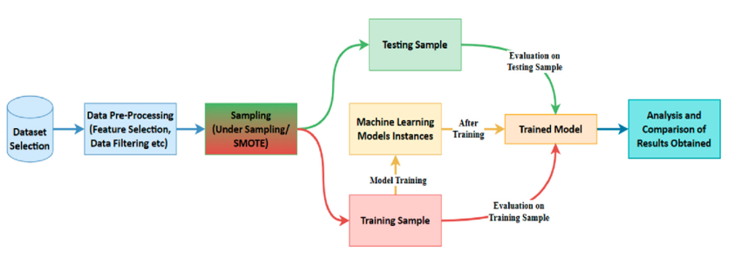

**6.3** Data Pipeline Design

#### a) Data Ingestion

The data ingestion component is responsible for collecting transaction data from various sources such as banks, payment gateways, and merchant systems. This process is often facilitated by tools like Apache Kafka or AWS Kinesis, which enable real-time data streaming. Below is a simple diagram illustrating the data ingestion process:

+-------------+ +---------------------+

| Data Source | --- > | Data Ingestion Layer|

+-------------+ +---------------------+

| Real-time Streaming |

| Processing |

+---------------------+

#### b)Data Storage Solutions

Data storage solutions provide scalable storage for both raw and processed data. Common options include cloud-based services like AWS S3, Google Cloud Storage, or Hadoop Distributed File System (HDFS). The diagram below outlines a typical data storage architecture:

+-------------------+

| Data Storage |

| |

| Raw Data |

| |

+--------------------+

| Processed Data |

+-------------------+

#### c)Data Preprocessing Steps

Data preprocessing involves cleaning, normalizing, and enriching the raw transaction data to prepare it for further analysis. This process often includes handling missing values, removing duplicates, and scaling numerical features. Below is a simplified representation of data preprocessing steps:

+----------------------+

| Data Preprocessing|

| |

| Clean Data |

| Normalize Data |

| Handle Missing |

| Values |

+-----------------------+

#### d)Feature Engineering Pipeline

The feature engineering pipeline extracts relevant features from the preprocessed data to create input variables for the machine learning models. This may involve aggregating transaction data, generating time-based features, and creating behavioral patterns. Here's a basic depiction of the feature engineering pipeline:

+---------------------+

| Feature Engineering |

| |

| Extract Features |

| Aggregation |

| Temporal Features |

| Behavioral |

| Patterns |

+---------------------+

These diagrams provide a visual representation of the data pipeline design for the credit card fraud detection project, making it easier to understand the flow and interactions between different components.

### 6.4 Model Design

#### a)Model Selection Criteria

Model selection criteria involve choosing the most appropriate algorithms based on factors like performance, interpretability, and scalability. The diagram below illustrates the factors influencing model selection:

+-----------------------------+

| Model Selection Criteria |

+-----------------------------+

| Performance Metrics |

| Interpretability |

| Scalability |

| Domain Suitability |

+-----------------------------+

#### b)Detailed Description of Algorithms

This section provides a detailed explanation of the machine learning algorithms chosen for the fraud detection model. Each algorithm is described in terms of its underlying principles, strengths, and weaknesses. Here's a simple diagram illustrating this:

+-------------------------------+

| Detailed Description of |

| Machine Learning |

| Algorithms |

+-------------------------------+

| Algorithm 1 |

| Description |

| Algorithm 2 |

| Description |

| Algorithm 3 |

| Description |

+-------------------------------+

#### c)Ensemble Methods

Ensemble methods combine multiple base models to improve prediction accuracy and robustness. Common techniques include bagging, boosting, and stacking. Below is a representation of ensemble methods:

+----------------------+

| Ensemble Methods |

+----------------------+

| Bagging |

| Boosting |

| Stacking |

+----------------------+

#### d)Hyperparameter Tuning Strategy

Hyperparameter tuning involves optimizing the parameters of machine learning algorithms to achieve the best performance. Strategies include grid search, random search, and Bayesian optimization. Here's a depiction of hyperparameter tuning:

+-------------------------+

| Hyperparameter Tuning |

+-------------------------+

| Grid Search |

| Random Search |

| Bayesian Optimization |

+-------------------------+

These diagrams provide a visual representation of the model design components in the credit card fraud detection project, aiding in understanding the selection criteria, algorithms, ensemble methods, and hyperparameter tuning strategy.

* 1. **Real-Time Processing**

1. **Streaming Data Pipeline**: Set up a real-time streaming pipeline using technologies like Apache Kafka or Apache Flink to ingest continuous streams of transaction data from multiple sources.
2. **Real-Time Data Processing Techniques**: Implement real-time data processing algorithms such as anomaly detection algorithms (e.g., Isolation Forest, Local Outlier Factor) to analyze incoming transaction data for potential fraudulent activity.
3. **Integration with Real-Time Databases**: Integrate the streaming pipeline with real-time databases like Apache Cassandra or MongoDB to store and retrieve transaction data in real-time for quick access during fraud detection processes.

**6.5 A**nomaly Detection Mechanisms

a) **Anomaly Detection Algorithms**: Utilize machine learning algorithms like Isolation Forest, One-Class SVM, or autoencoders to detect abnormal patterns in credit card transactions, distinguishing fraudulent from legitimate activities based on features such as transaction amount, location, and frequency.

b) **Scoring and Threshold Mechanisms**: Implement scoring systems that assign anomaly scores to each transaction based on its deviation from normal behavior, setting dynamic thresholds to classify transactions as either normal or potentially fraudulent.

**c)** **Handling False Positives**: Implement post-processing techniques such as rule-based filtering or manual review processes to reduce false positives, ensuring that legitimate transactions are not incorrectly flagged as fraudulent.

d) **Handling False Negatives**: Develop mechanisms to handle false negatives by incorporating real-time feedback from fraud investigations or leveraging external data sources to improve model sensitivity and reduce missed fraud cases.

* 1. System Components

1. • **Data Collection Component**: This component gathers real-time credit card transaction data from various sources, including online payment gateways and POS terminals, ensuring a continuous flow of data for fraud detection analysis.
2. • **Feature Engineering Component**: Responsible for extracting relevant features from transaction data, such as transaction amount, location, and time, and transforming them into meaningful representations to improve the accuracy of fraud detection models.
3. • **Model Training Component**: Utilizes historical transaction data to train machine learning models, such as logistic regression or random forests, to learn patterns indicative of fraudulent activity, enabling the system to detect potential fraud in real-time.
4. • **Model Evaluation Component**: Assess the performance of trained models using evaluation metrics like precision, recall, and ROC curves, ensuring that the models effectively distinguish between fraudulent and legitimate transactions before deployment.
5. • **Deployment Component**: Once trained and evaluated, deploy the fraud detection models into the production environment, integrating them with the real-time transaction processing system to identify and flag potentially fraudulent transactions as they occur.

**6.7** API Design

1. **API Endpoints**: Define RESTful endpoints such as "/detect-fraud" to allow external systems to interact with the fraud detection system, triggering fraud detection processes and receiving responses.
2. **Request and Response Formats**: Specify JSON or XML formats for incoming requests containing transaction data and define standard response structures indicating the likelihood of fraud for each transaction.
3. **Authentication and Authorization**: Implement authentication mechanisms such as OAuth or API keys to verify the identity of clients accessing the API and enforce access control policies to ensure only authorized users can submit transactions for fraud detection.

**6.8 User Interface Design**

a) **Dashboard Layout**: Design a user-friendly dashboard displaying key metrics and visualizations, such as transaction volumes and fraud detection rates, to provide stakeholders with a comprehensive overview of the credit card fraud detection system's performance.

b) **User Interaction Flow**: Create intuitive user interaction flows guiding analysts through the process of investigating flagged transactions, providing clear steps for reviewing transaction details and determining the validity of fraud alerts.

c) **Alert and Notification System**: Implement an alert system to notify fraud analysts in real-time via email or SMS when potentially fraudulent transactions are detected, facilitating prompt investigation and response to suspicious activity.

**6.8 Security Considerations**

a) **Data Encryption**: Employ strong encryption algorithms like AES to encrypt sensitive credit card data both at rest in databases and during transmission, ensuring confidentiality and preventing unauthorized access.

b) **Secure Data Transmission**: Implement secure communication protocols such as HTTPS/TLS to encrypt data transmitted between client applications and servers, safeguarding against eavesdropping and data interception during transmission.

c) **Access Controls**: Enforce role-based access controls (RBAC) and least privilege principles to restrict access to sensitive data and system functionalities, ensuring that only authorized users have the necessary permissions to perform specific actions within the credit card fraud detection system.

6.9 UML DIAGRAMS:

a) USECASE DIAGRAM:

Use case diagrams can be created using the same tools mentioned above. Begin by identifying the actors and use cases relevant to your credit card fraud detection system. Actors could include fraud analysts, administrators, and the system itself. Use the chosen tool to create shapes representing actors and use cases, and then connect them with lines to show the relationships and interactions.

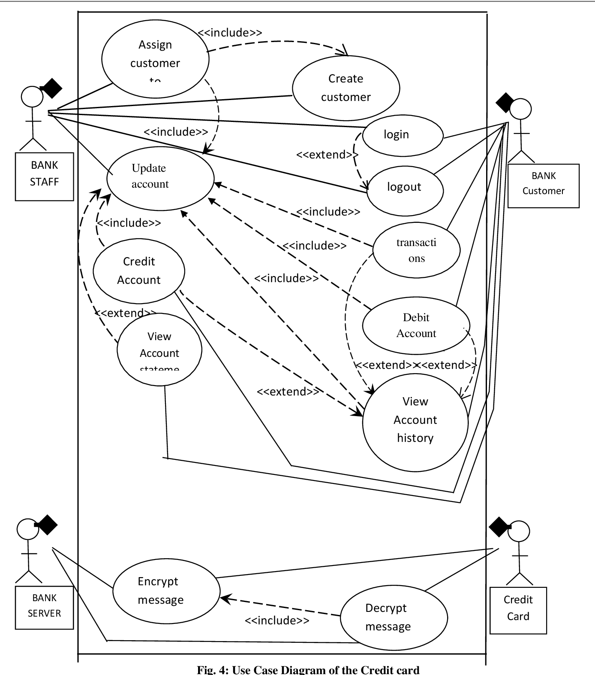

### b) Sequencial Diagram:

### Sequence diagrams can be created using tools like Visual Paradigm, UMLet, or even drawing software like Microsoft PowerPoint. Start by identifying the components or objects involved in the sequence of interactions, such as data processing modules, external systems, and users. Then, use the chosen tool to draw lifelines representing these components and connect them with arrows to illustrate the sequence of messages exchanged between them.

### 

### C) Activity Diagram:

### Activity diagrams can also be created using tools like Microsoft Visio, Lucidchart, or draw.io. Begin by identifying the activities or actions involved in the credit card fraud detection process, such as data preprocessing, feature engineering, model training, and alert generation. Then, use the chosen tool to draw shapes representing these activities and connect them with arrows to show the flow of control between them.

### Fraud detection activity diagram | Download Scientific Diagram

### 6.10 System Architecture

a) **High-Level Architecture Diagram**: A visual representation showcasing the major components and their connections within the credit card fraud detection system, offering a bird's-eye view of the system's structure.

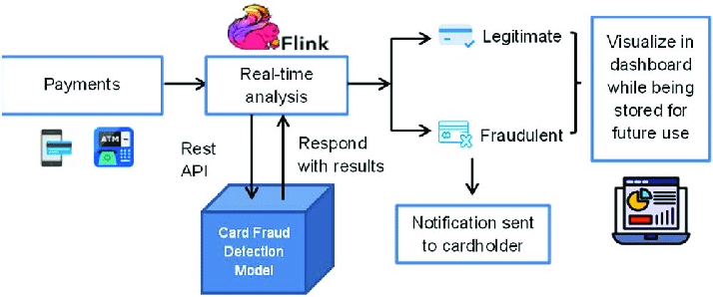

b) **Components and Their Interactions**:

Once the model passes the evaluation gate, to bring it to a higher practical level, we designed a pipeline showing how the detection result will be used when it is deployed. The implementation is illustrated in Figure 9.

Step 1: The user makes a payment for their transactions by credit card, which is recorded and fed into a real-time processing system using Apache Flink, a large-scale data processing platform that can process the generated data at very high speed with low latency.

Step 2: The proposed credit card fraud detection model is implemented as an API, and Apache Flink calls this API to process and output the results received from the model.

Step 3: If the transaction is detected to be fraudulent, the system sends the user a warning alert at the time of payment by asking whether the user who initiated the payments was the cardholder. If the user does not make a transaction, the user’s account will be locked; otherwise, the transaction is regarded as legitimate. In the event that a signal is not received from the user, the account will be temporarily locked until the user agrees that the transaction has just been paid by the cardholder.

Step 4: The prediction results were saved to the database and presented as a dashboard for analysis.

**6.11 Database Design**

* **Data Handling Policies**: Define policies governing how credit card transaction data is handled, including data retention periods, access controls, encryption standards, and compliance with regulatory requirements such as PCI DSS.
* **Data Backup Strategy**: Develop a strategy for regular backups of transaction data to ensure data integrity and availability in case of system failures or data loss incidents.
* **Recovery Procedures**: Outline procedures for recovering data from backups in the event of a system outage, data corruption, or other disasters, ensuring minimal disruption to fraud detection operations and timely restoration of services.

### 6.12

**System Interface Design**

* **API Design**: Define the endpoints, request and response formats, authentication mechanisms, and access controls for the API through which external systems interact with the credit card fraud detection system.

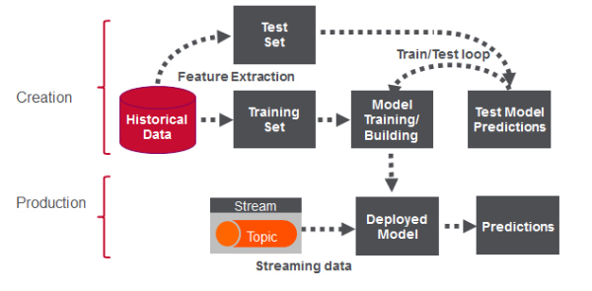

* **User Interface Design**: Design a user-friendly interface, such as a web-based dashboard or application, for fraud analysts and administrators to interact with the system, facilitating tasks such as reviewing flagged transactions, adjusting detection parameters, and generating reports.

### The architecture of the proposed credit card fraud detection ...

**6.13 Critical Considerations**

* **Compliance Requirements**: Ensure adherence to relevant compliance standards such as PCI DSS (Payment Card Industry Data Security Standard) to protect sensitive credit card data and meet regulatory obligations.
* **Scalability Strategies**: Develop strategies to scale the credit card fraud detection system to handle increasing transaction volumes and accommodate future growth, using techniques such as horizontal scaling, cloud computing, and distributed processing.
* **Monitoring and Maintenance**: Implement robust monitoring tools and procedures to continuously monitor system performance, detect anomalies, and proactively address issues, alongside establishing regular maintenance schedules to ensure system reliability, security, and performance optimization.

**6.14 Design Documentation Summary**

* **Key Design Decisions**: Document key decisions made during the design phase of the credit card fraud detection system, including architectural choices, technology selections, and implementation strategies.
* **Summary of Design Phase Outcomes**: Provide a concise summary of the outcomes and deliverables of the design phase, highlighting achievements, milestones reached, and any remaining tasks or considerations for subsequent phases of the project.